

**USER MANUAL SIGN-OFF**

**Authorization Memorandum**

This form is to sign-off completion of the Design Phase for **CAMPUS MANAGEMENT SOFTWARE AT WORLD SKILL CENTER (WSC).**

World Skill Centre (WSC) acknowledges receipt of the deliverables as part of the Design Phase through the submission of this document.

|  |  |
| --- | --- |
| **MODULE NAME** | Faculty Workload |
| **MODULE OWNER** |  |

**WSC AUTHORITY NAME AND SIGNATURE**

**SOUL AUTHORITY NAME AND SIGNATURE**

**Sustainable Outreach And Universal**

**Leadership (SOUL) Limited**

**User Manual**

Of

**Faculty Workload Module**

For Implementation of

**Campus Management Software**

at

**World Skill Center (WSC)**

**Confidentiality**

This document is a strictly confidential communication to and solely for the use of the recipient and may not be reproduced or circulated without SOUL Ltd’s prior written consent. If you are not the intended recipient, you may not disclose or use the information in this documentation in any way

**Document Control History**

|  |  |  |  |  |
| --- | --- | --- | --- | --- |
| **Date** | **Version No.** | **Created By** | **Affected Sections** | **Reviewed By** |
|  |  |  |  | Sharmistha Panda |

Table Of Contents

USER MANUAL SIGN-OFF 1

Authorization Memorandum 1

1 Introduction 5

1.1 Background 5

1.2 Scope and Purpose of the document 5

2 General Procedures 6

2.1 General Procedure for Save Screen 6

2.2 General Procedure for Submitted Document 11

3 Faculty Workload 14

3.1 Faculty Work Assignment 14

4 Reports 15

4.1 Instructor Workload report 15

5 Roles and Permissions 16

5.1 Faculty Work Assignment 16

5.2 Instructor Workload report 16

# Introduction

The World Skill Center (WSC) is a premier advanced skill training institute established by the Government of Odisha, Skill Development and Technical Education Department, through the Odisha Skill Development Authority (OSDA). The WSC will impart advanced skill training in eight trades from engineering and service sectors. WSC caters primarily to induct the best talent from ITIs and Polytechnics and training them to become globally employable in emerging areas such as "Industry 4.0". WSC is housed in a state-of-the-art, 18-storey, air-conditioned building with nearly half a million square feet of space in the heart of capital city of Bhubaneswar.

With the implementation of campus management software for WSC the goal is to streamline the operations and functions of the campus by integrating various processes, such as admissions, course registration, academic progress tracking, and financial management, HRMS, Procurement and Inventory management, etc into a unified system. The implementation also aims at providing a user-friendly interface for all stakeholders, making it easier for them to access the necessary information and complete their tasks with ease. The modules to be covered during the implementation of the software include:

|  |  |
| --- | --- |
| Students Management Modules | Infrastructure Management |
| Academic System | Finance and Accounting System |
| Procurement & Inventory Management | Training and Placement |
| Human Resources Management System | Application Integration |

# 

## Background

The Web Based Campus Management Application at World Skill Centre (WSC) application is required by WSC for the smooth operation of all departments / support functions with on-line delivery of services to all stakeholders.

The project aims to create a mechanism to provide the basis for evolution of an IT enabled state of the art workflow automation system in a planned manner.

## Scope and Purpose of the document

A user manual is a document provided to a user that helps in using a particular system, product or service seamlessly. It is also known as an instruction manual or a user guide. Such documents cover detailed information around operations, standards & guidelines, [troubleshooting guides](https://document360.com/blog/troubleshooting-guide/" \t "https://document360.com/blog/creating-a-user-manual/_blank), functionalities & more.

This document covers all the aspects of HRMS module. This module helps in organizing the entire HRMS setup such as Masters,Employee Lifecycle,Leave Management,Shift Management,Appraisal and Recruitment process.

The scope of HRMS Module:

* **Faculty workload (specific functionalities and features that the "Faculty Workload" system should possess. It covers various use cases, such as faculty assignment management, workload distribution, reporting, and administrative tasks. Each requirement is described in detail, including inputs, outputs, and system responses.)**

# General Procedures

## General Procedure for Save Screen

**Create New document**

Login on to the system

Go to the required workspace

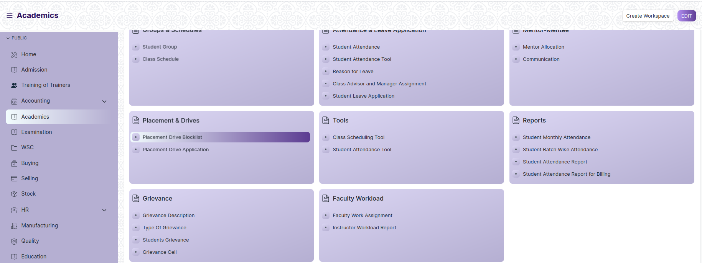

* Go to the required screen.
* Click on the ***“+Add Screen Name”*** button in the right corner of the screen.

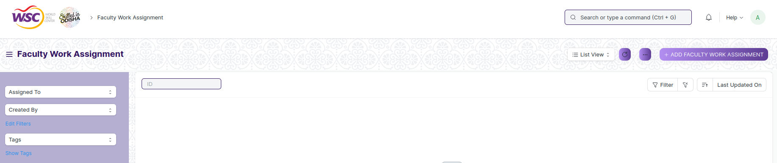

(Example : For addition in the new Faculty Work Assignment Type , click +Add Faculty Work Assignment button).

* Enter the required data.
* Click on “***Save”*.**
* After saving , the record will be visible in the List View of the screen.

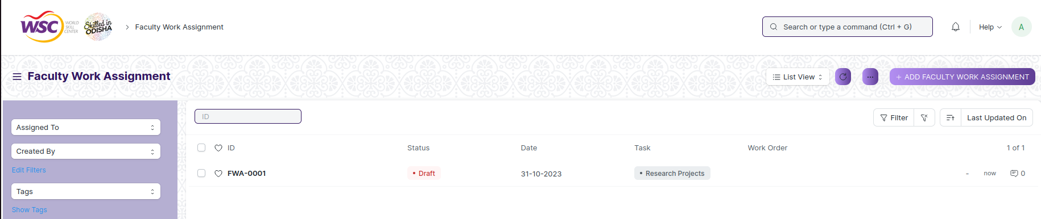(Example : List view of Faculty Work Assignment)

**Note :** The process of creation can only be carried out by employees who have necessary permission.Kindly refer to the Screen wise permission section in the document.

**View a Saved Document**

* Log in to the system.
* Go to the required workspace
* Go to the required screen.
* Click on the required document from the list view of the screen.



(Example : View of “FWA-001” Faculty Work Assignment Screen)

View the clicked document.

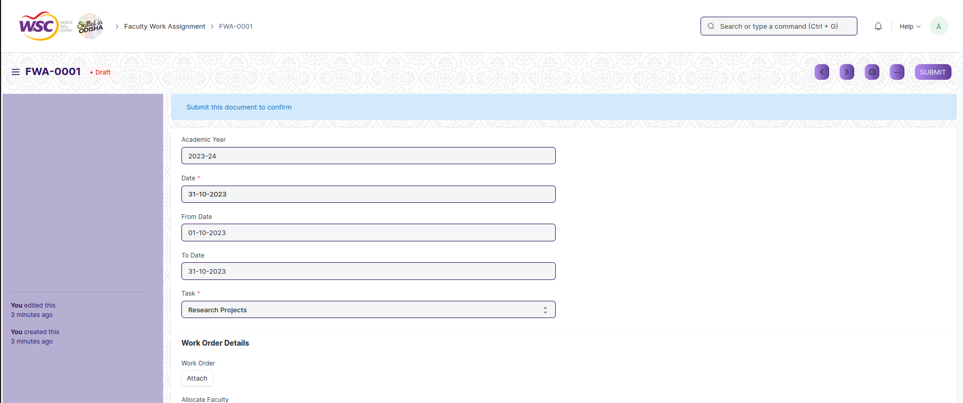

(Example : View of the “FWA-001” Faculty Work Assignment)

**Note :** The process of view can only be carried out by employees who have necessary permission.Kindly refer to the Screen wise permission section in the document.

**Delete a Saved Document**

* Log in to the system
* Go to the required workspace
* Go to the required screen.
* Click on the required document from the list view of the screen.
* Click on the 3 dots in the right corner of the screen.
* Click on *“****Delete”*.**

**Note :** If the document you are deleting is linked with any other document then first unlink it , then try to delete.

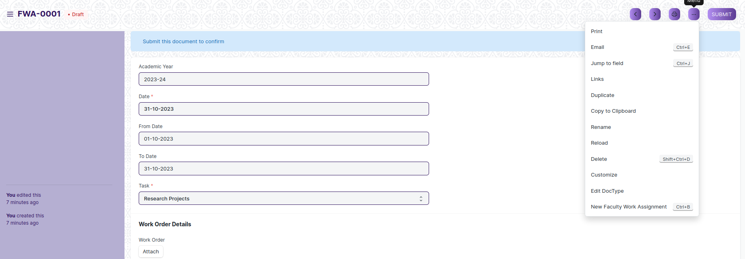

(Example : Deletion of “FWA-001” document of Faculty Work Assignment)

* Click yes if you want to delete the selected document.

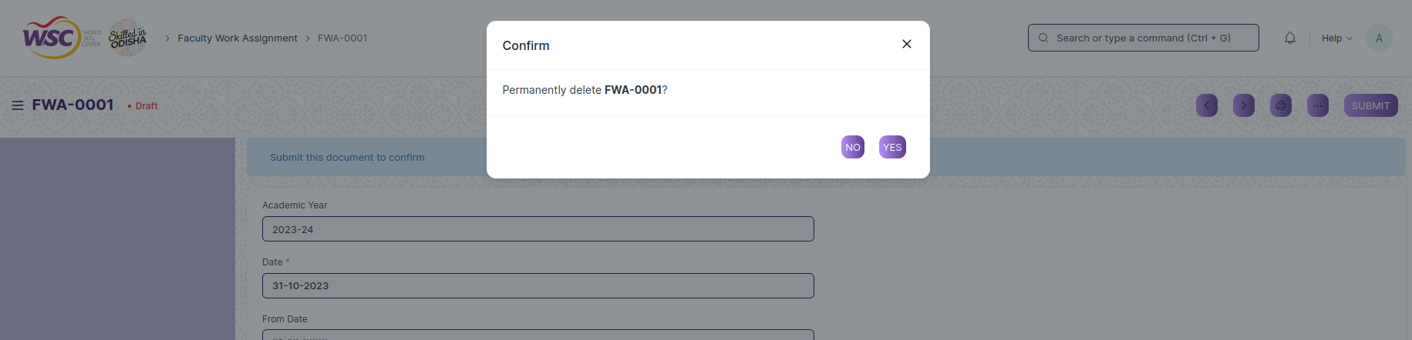

(Example : Clicking Yes to Delete permanently the document)

**Note :** The process of deletion can only be carried out by employees who have necessary permission.Kindly refer to the Screen wise permission section in the document.

**Rename a Saved Document**

* Login to the screen.
* Go to the required workspace
* Go to the required screen.
* Click on the required document from the list view of the screen.
* Click on the 3 dots in the right corner of the screen.
* Click on *“****RENAME”*** .



* Click on *“****Rename”*** button to rename the document.

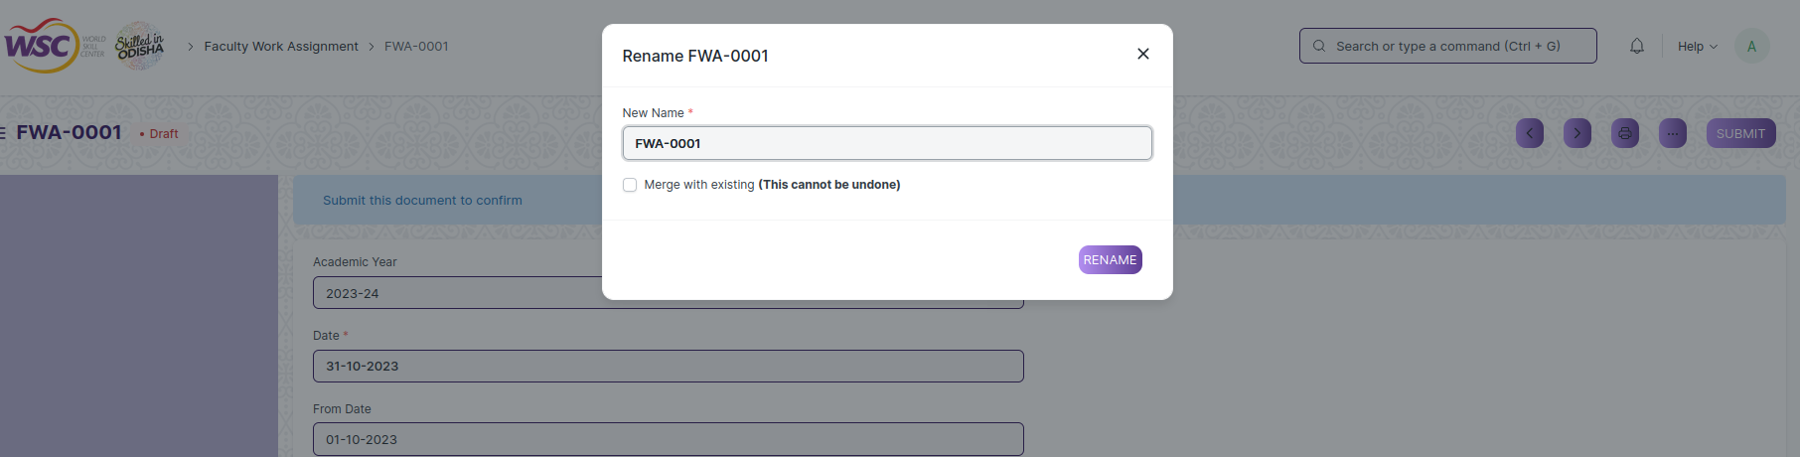

**Note :** The process of deletion can only be carried out by employees who have necessary permission.Kindly refer to the Screen wise permission section in the document.

**Print a Saved Document type**

* Login to the system
* Go to the required workspace
* Go to the required screen.
* Click on a saved document on the screen.
* Click on the print button presented in the right corner of the screen.

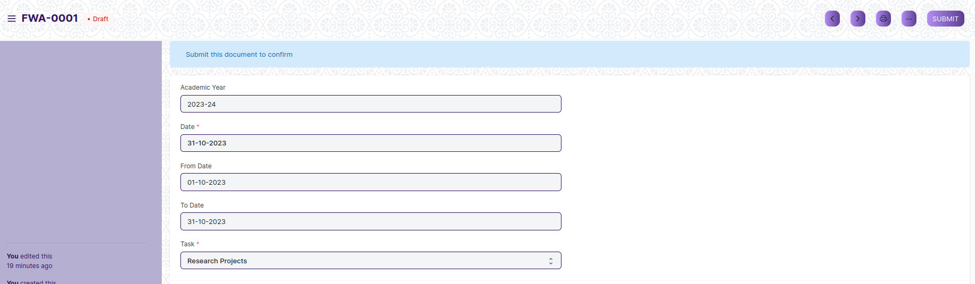

* A new screen will open.
* Click on the print button to print the document.

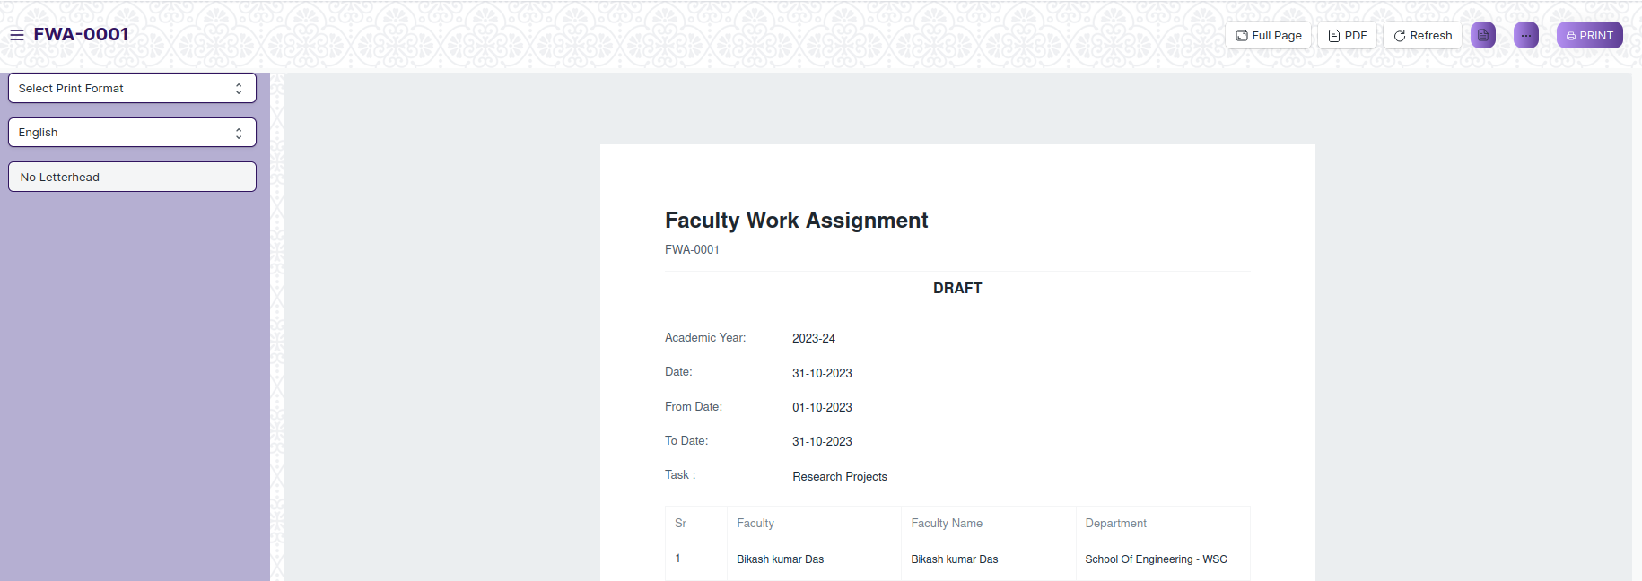

* To download the employment type as PDF , click on the PDF button .



**Note :** The process of printing can only be carried out by employees who have the necessary permission.

**View the saved document in different format.**

* Login to the system
* Go to the required workspace
* Go to the required screen.
* Click on the List View Button in the screen.

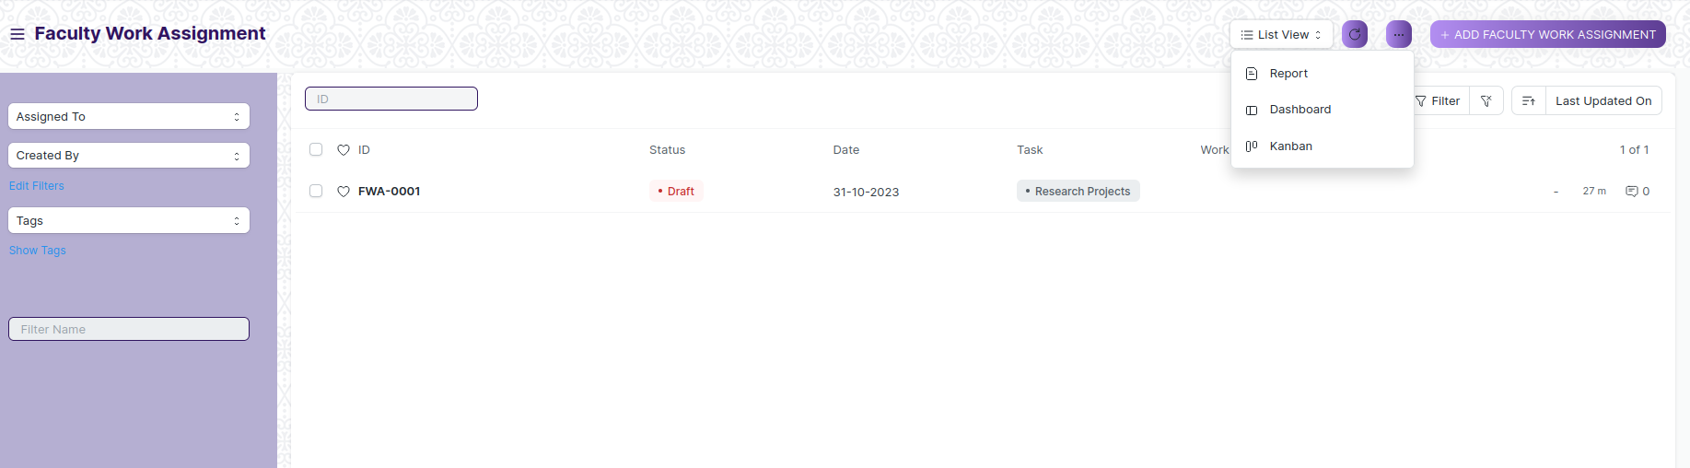

* Select the appropriate view type that you want.

**Note :** The List view button can only be showed to the employees who have necessary permission.

**View the saved documents by applying filters.**

* Login to the screen.
* Go to the required workspace.
* Go to the required screen.
* Click on the ***“Filter”***.

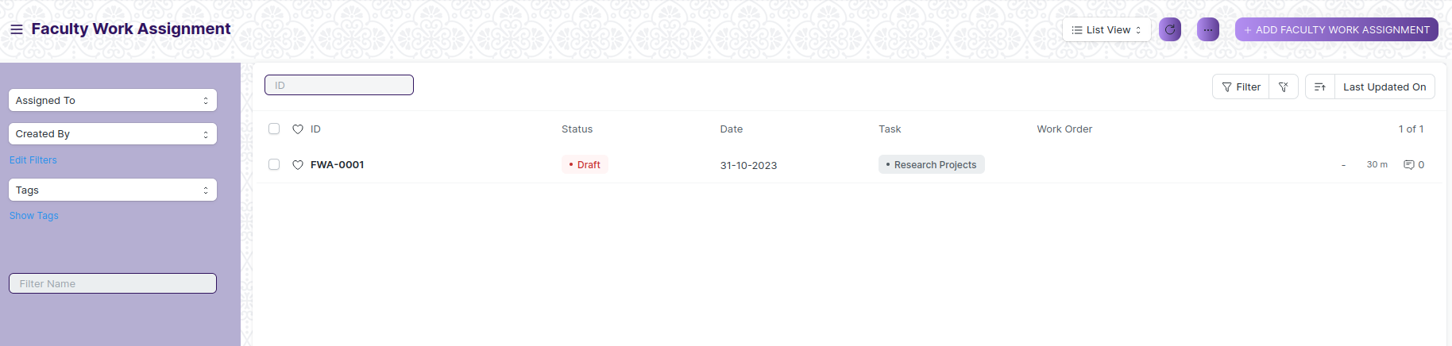

* Select the field of the document based on which you wish to filter the records. All the fields in a form will be selectable in this list.

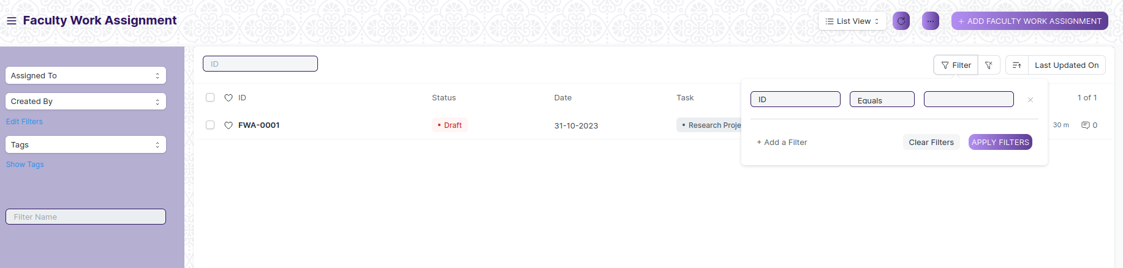

Value

Based on

Criteria

**Based On :** For the field, you will be required to put a value of the field. In the 'based on' field.

**Criteria :** You can define criteria based on which the system will search the document.The different conditions on which the filters are based are: Equals, Not Equal, Like, Not Like, In, Not In, =,>,< etc.

**Value :** Here, you will be required to enter the value for which you are running the document search.

**Some Examples of Viewing the documents in the list view after applying filters.**

Filter on Faculty Work Assignment screen where ID Equals to FWA-001. After clicking the Apply Filter button, all the filtered document will show in the screen.

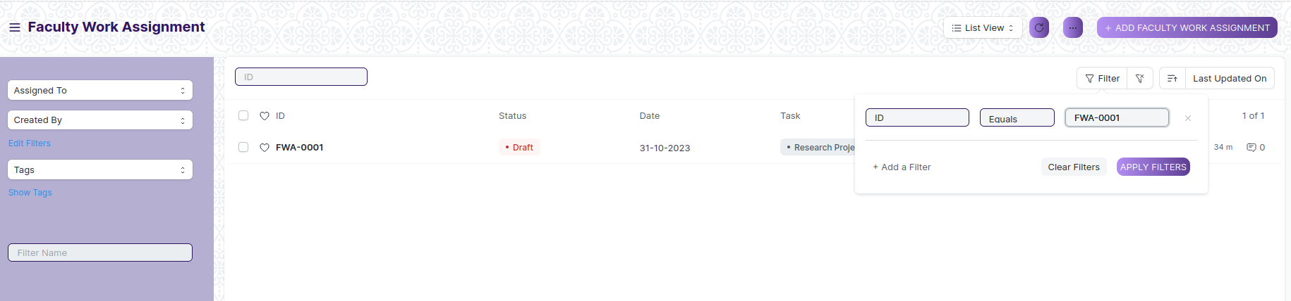

You can also apply multiple filters at a time. To remove a specific filter, just click on 'x' sign on it. To add another filter Click on the +Add a Filter button.

**Example of Multiple filter .**

Applying filter in the Faculty Work Assignment screen , where ID equals to FWA-001 and Date equals to 31.10.2023.

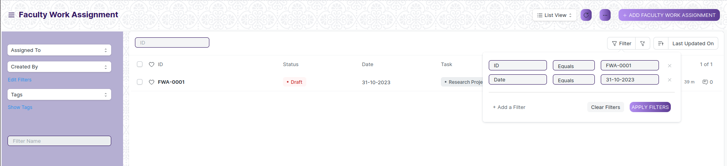

**Default Filters**

There are some filters present out of the box for the views which can be used for filtering the search results.

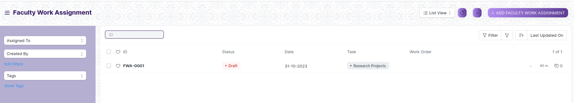

**Note :** The Filter Option can only be showed to the employees who have necessary permission.

## General Procedure for Submitted Document

**Create of New document**

* Login in to the system
* Go the required workspace
* Go to the required screen.
* Click on the ***“+Add Screen Name”*** button in the right corner of the screen.

(Example : For addition in the new Employment Type , click +Add Employment Type button).

* Enter the required information in the document.
* Once you are finished entering the information , click the ***“Save”*** button.
* After saving it , a submit button will appear.

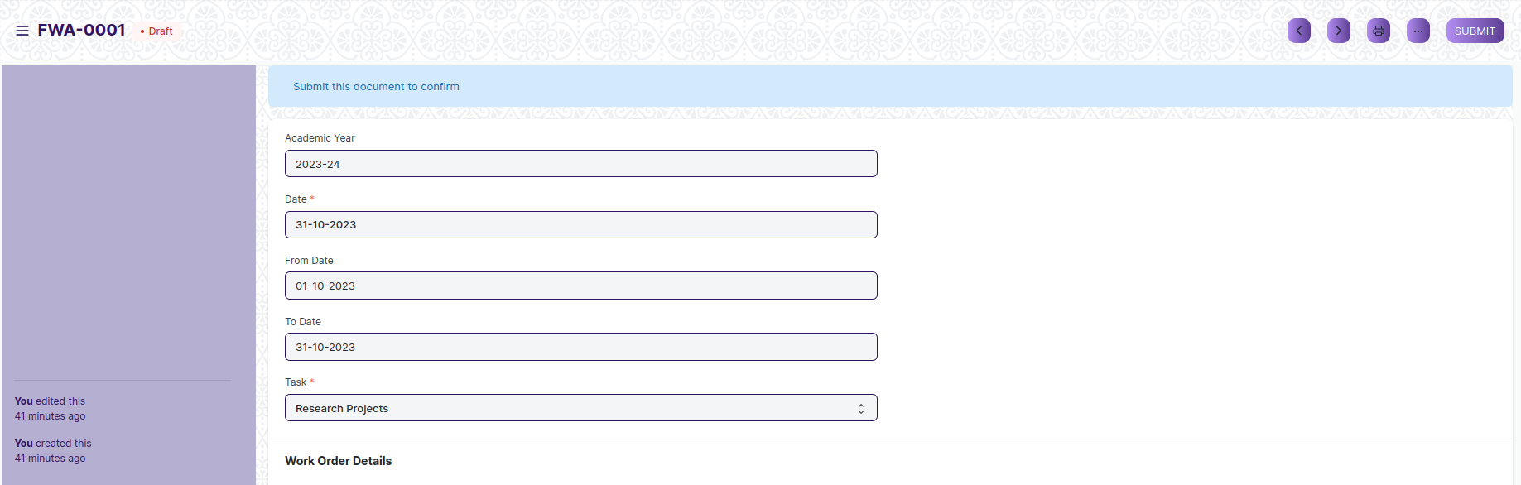

* Click on the **“Submit”** button.
* A confirmation dialog box will appear . Click the Yes button to submit the document.

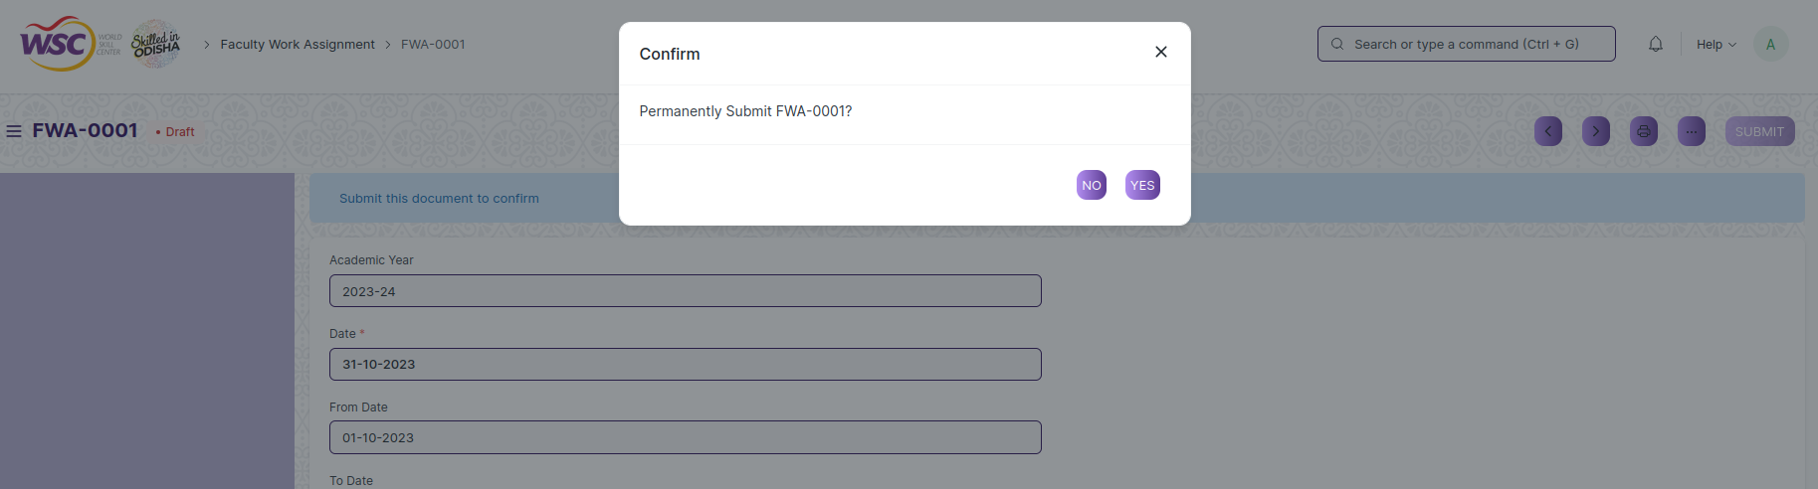

* After submitting , the record will be visible in the List View of the screen.

**Note :** The process of creation can only be carried out by employees who have necessary permission.Kindly refer to the Screen wise permission section in the document.

**Cancel a Submitted Document**

* Log in to the system.
* Go to the required workspace
* Go to the required screen.
* Click on the required document from the list view of the screen.
* Click the ***“Cancel”*** Button .

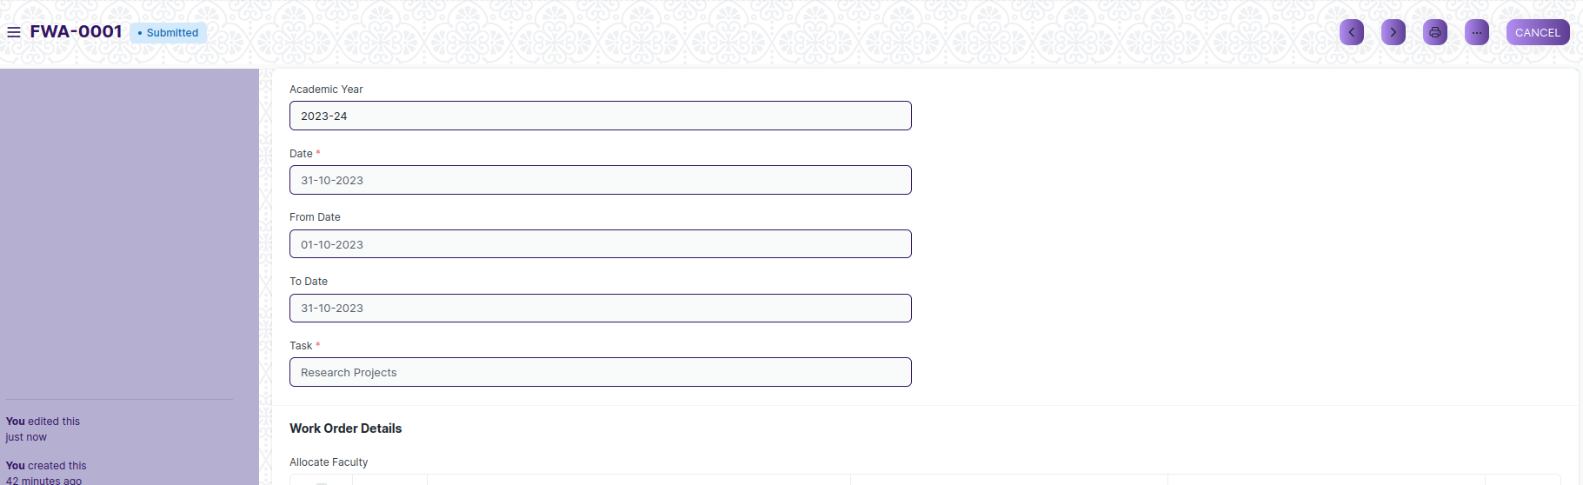

* A confirmation dialog box will appear . Click the Yes button to cancel the document.

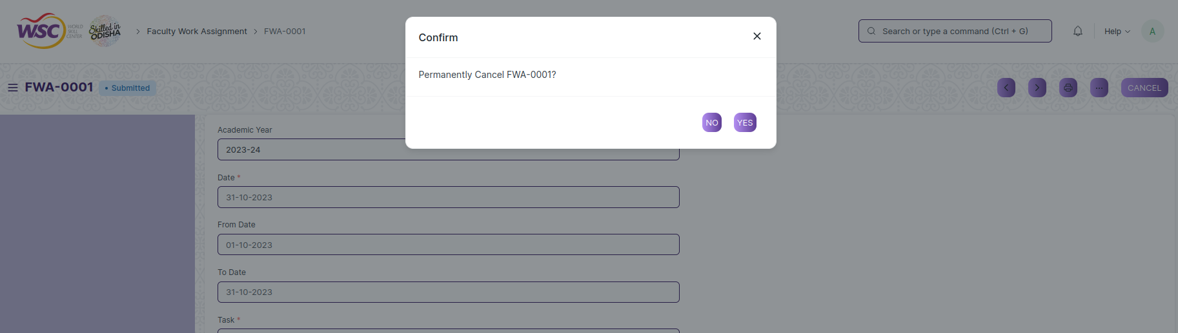

**Note :** The process of cancellation can only be carried out by employees who have necessary permission.Kindly refer to the Screen wise permission section in the document.

**Amend a Submittable Document**

* Log in to the system.
* Go to the required workspace
* Go to the required screen.
* Click on the required document from the list view of the screen.
* After cancellation of the document , an Amend button will appear on the screen.

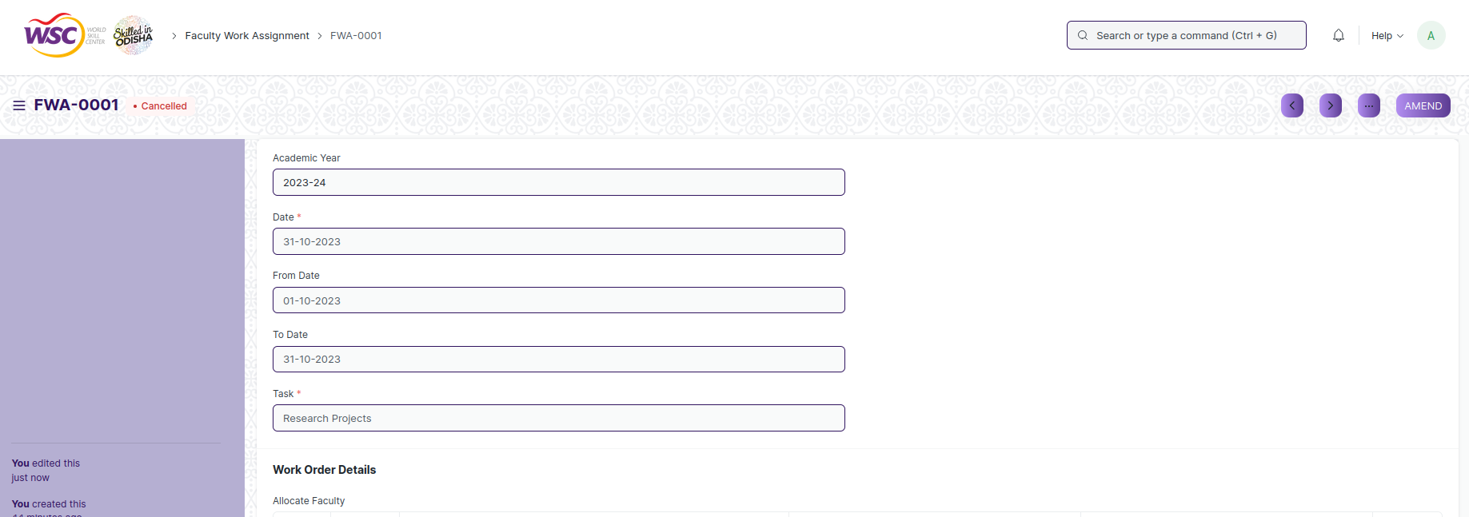

* Click the “***Amend”*** button.
* A new document will be created with the same information as the original document .

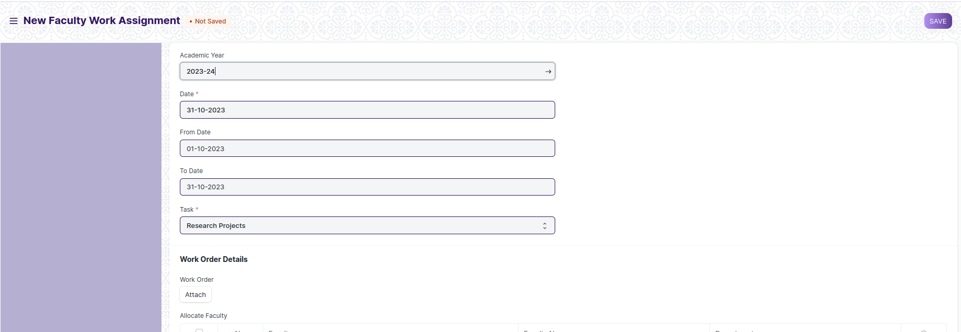

* You can now make changes to the document as needed.

**Note :** The process of Amend can only be carried out by employees who have necessary permission.Kindly refer to the Screen wise permission section in the document.

**Action Menu on a document.**

The three dots menu, located in the right corner of a document in a Screen , offers a range of actions and options to manage and interact with the document.

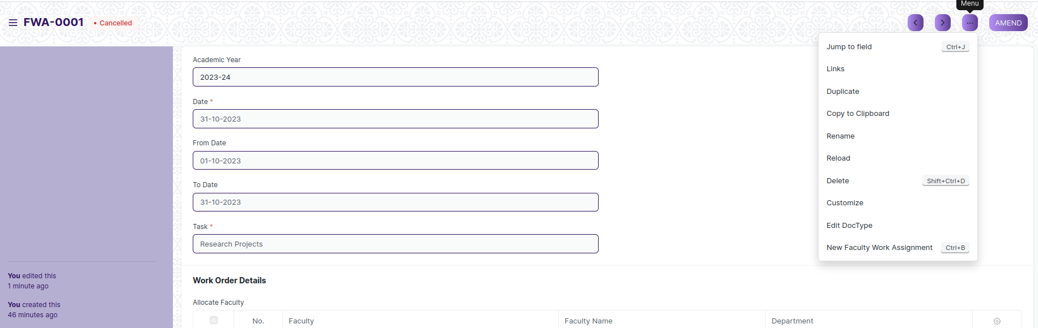

The functionalities available in the three dots menu are given below .

**Print :** Print Enables you to generate a printable version of the document ., which you can save as a PDF or send to a printer.

**Email :** Click on Email allows you to send the document as an attachment via email to specified recipients.

**Duplicate :** Create a new document with the same information as the current one.

**Delete :** Permanently remove the document.

**Cancel :** Cancel the submitted document.

**Submit :** Submit the document . If the document is submittable.

**Links :** This Option displays a list of document that are linked to the current document. You can navigate these linked documents from here.

**Jump to field :** You can directly go the required field by clicking this option and giving appropriate field name.

**Copy to Clipboard :** By clicking this option you can copy the content of the document .

**Rename :** By clicking the Rename option you can Rename the document.

**Note :** These options will be visible to employees who have necessary permission.

# Faculty Workload

## Faculty Work Assignment

The faculty work assignment screen is a user interface within an educational institution's system or software that allows administrators or authorized personnel to assign tasks and responsibilities to faculty members.

The screen is accessible to HR Admin/Director Admin, HR Manager/CS, Reporting Authority, Employee.

To access the Faculty work assignment screen ,go to :

***Home>Academics>Faculty Workload>Faculty Work Assignment***

Screen Type : Submit

**Adding a new Employment Type**

As it is a save screen, follow the general procedure to create a save document as mentioned above .

* Go to the Faculty work assignment list, click on New.
* Enter Academic Year, Date, From date, To date, Task.
* Attach work order
* Enter Faculty based on which Faculty name and Department will be auto fetched.
* Save and Submit the form.

After creating an Employment Type , the record will be visible in the List view of the screen.

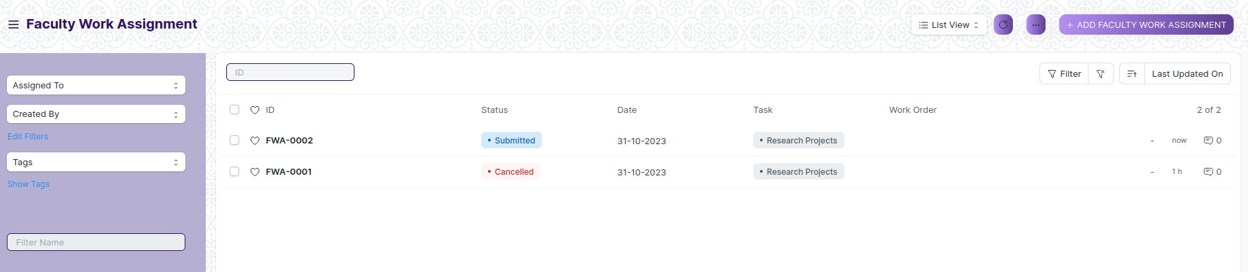

(List View of Faculty Work Assignment)

**View Faculty Work Assignment**

As it is a submit screen, follow the general procedure to view a submit document as mentioned above .

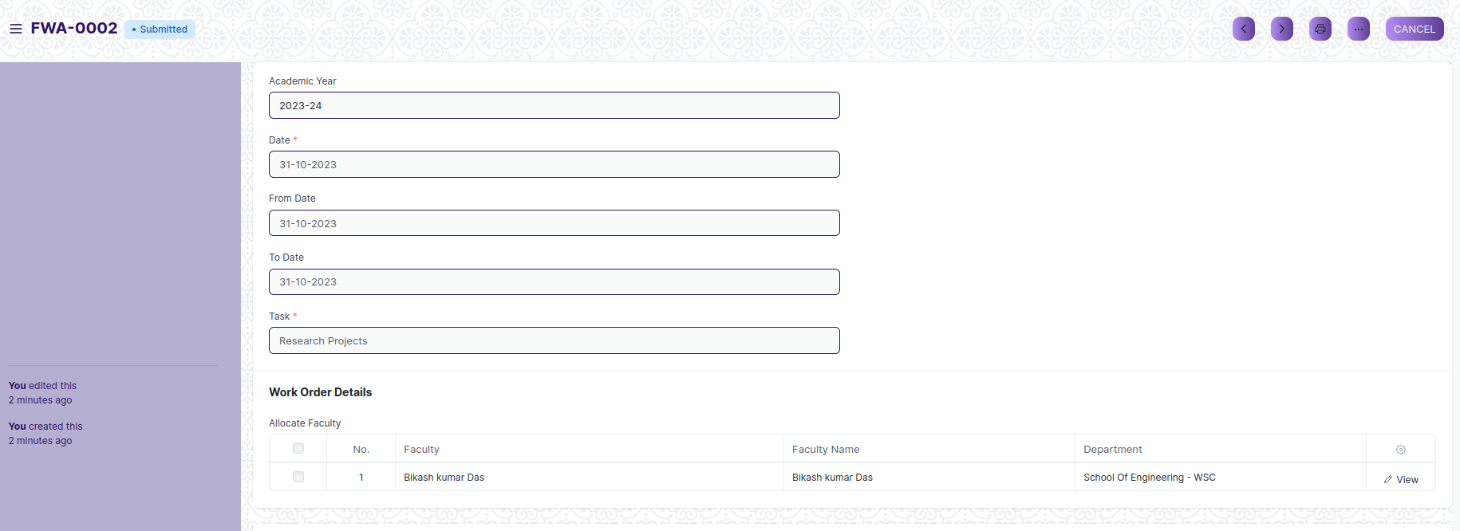

(View of a submitted Faculty Work Assignment)

**Delete Faculty Work Assignment**

As it a Submit screen , follow the general procedure to delete a submitted document .

**Edit Faculty Work Assignment**

Follow the steps to amend a submitted Faculty Work Assignment

Edit the field that you want to change.

Click on Save.

**Print Faculty Work Assignment**

As it is a submitted screen , follow the general procedure to print a submitted document.

# Reports

## Instructor Workload report

The instructor workload report may also include details about both teaching and non-teaching activities or responsibilities undertaken by the instructor.

It provides a comprehensive picture of the instructor's workload and distribution of their time and effort across various academic and non-academic tasks.

The screen is accessible by HR Admin/Director Admin, Department Head, Instructor

To access Instructor Workload report, go to:

***Home>Academics>Faculty Workload>Instructor Workload report***

**Screen:**

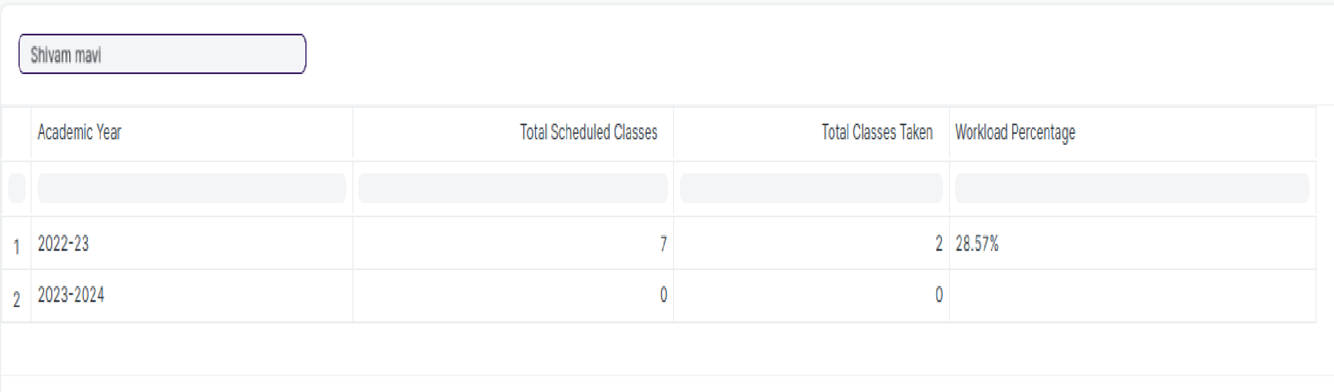

(view of Instructor workload report)

# Roles and Permissions

## Faculty Work Assignment

|  |  |  |  |  |  |  |  |  |  |
| --- | --- | --- | --- | --- | --- | --- | --- | --- | --- |
| **ID** | **Role** | **Select** | **Read** | **Write** | **Create** | **Delete** | **Submit** | **Cancel** | **Amend** |
| 1 | HR Admin/Director Admin | Yes | Yes | Yes | Yes | Yes | Yes | Yes | Yes |
| 2 | HR Manager/CS | No | Yes | Yes | Yes | No | Yes | Yes | Yes |
| 3 | Reporting Authority | Yes | Yes | Yes | No | No | Yes | No | No |
| 4 | Employee | No | Yes | No | No | No | No | No | No |

## Instructor Workload report

|  |  |  |  |  |  |  |  |  |  |
| --- | --- | --- | --- | --- | --- | --- | --- | --- | --- |
| **ID** | **Role** | **Select** | **Read** | **Write** | **Create** | **Delete** | **Submit** | **Cancel** | **Amend** |
| 1 | HR Admin/Director Admin | Yes | Yes | No | No | No | NA | NA | NA |
| 2 | Department Head | Yes | Read | No | No | No | NA | NA | NA |
| 3 | Instructor | No | Yes | No | No | No | NA | NA | NA |